CHAPTER 4: Chemical patterns
Worksheet 4.1

Periodic table
Student: Class:

Classifying the elements
1. Elements can be classified into groups called metals, non-metals and semi-metals (or metalloids). The following diagram illustrates the first four periods of the periodic table. Classify the elements labelled A–F as metals, non-metals or metalloids.
 |  |  |  |  |  |  |  |  |  |  |  |  | A |  |  |  | B
 | C
 |  |  |  |  | D |  |  |  |  |  |  |  | E |  |  | F
A:
B:
C:
D:
E:
F:

Family members
2. The following 12 elements belong to four different groups of the periodic table.
potassium, neon, sulfur, fluorine, tellurium, argon, lithium, oxygen, iodine, rubidium, helium, bromine
Sort these elements into their correct groups. In each column arrange the group members in order of increasing atomic weight.
CHAPTER 4: Chemical patterns
Worksheet 4.1

Page 2

Something in common
3. For each set of elements, state one characteristic that they have in common.

Set A
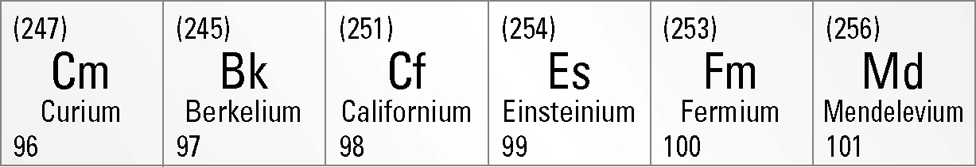

Set B
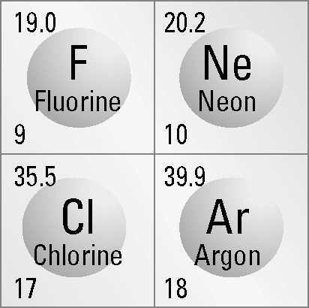

Set C
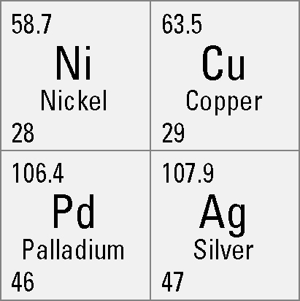

Set D
